Maintrix – UX Flow Notes

01 – Standard Login Screen
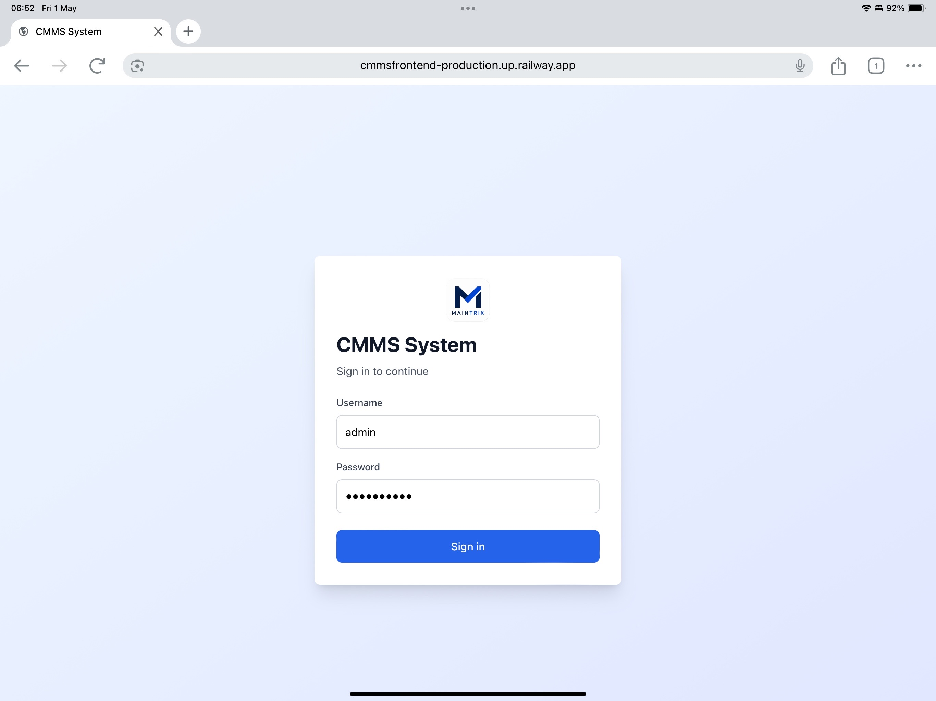

02 – Demo Mode / User Selection
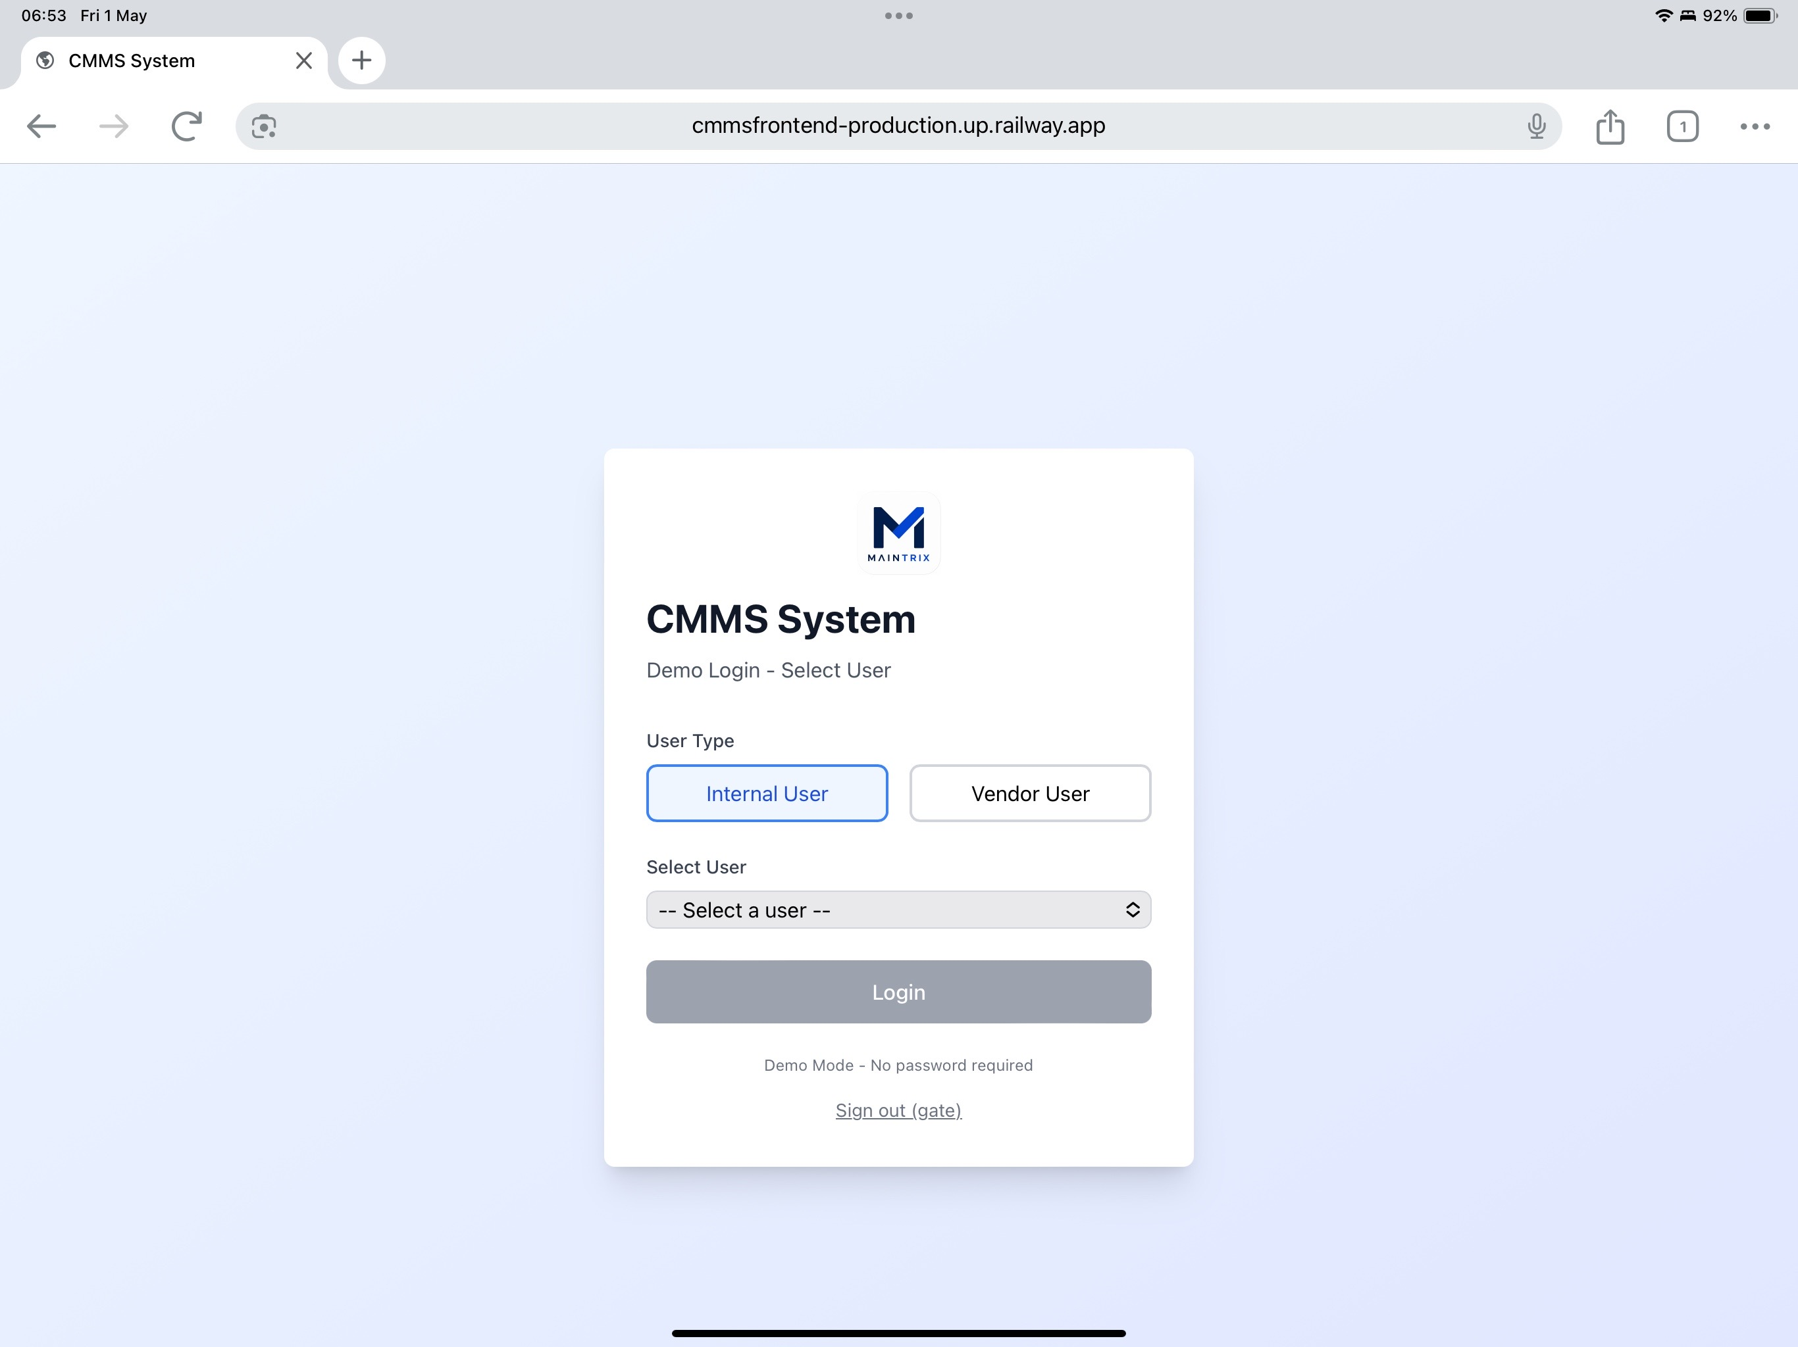

03 – Expanded User Selector
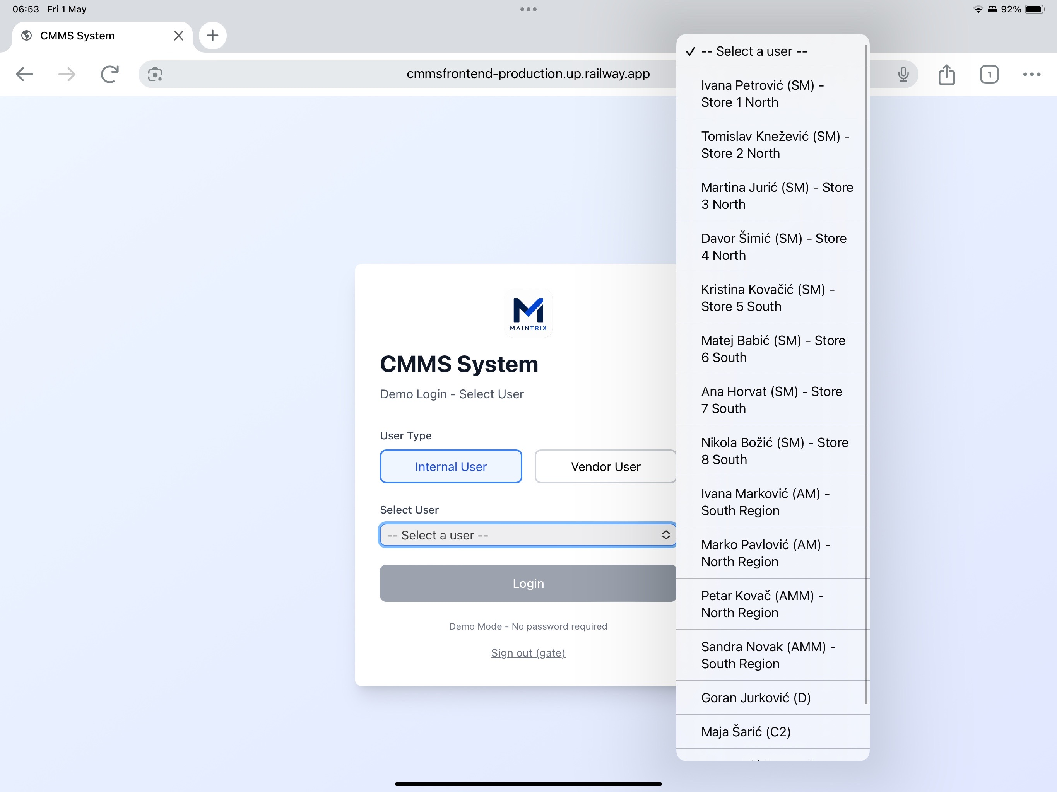

04 – Store Manager Dashboard
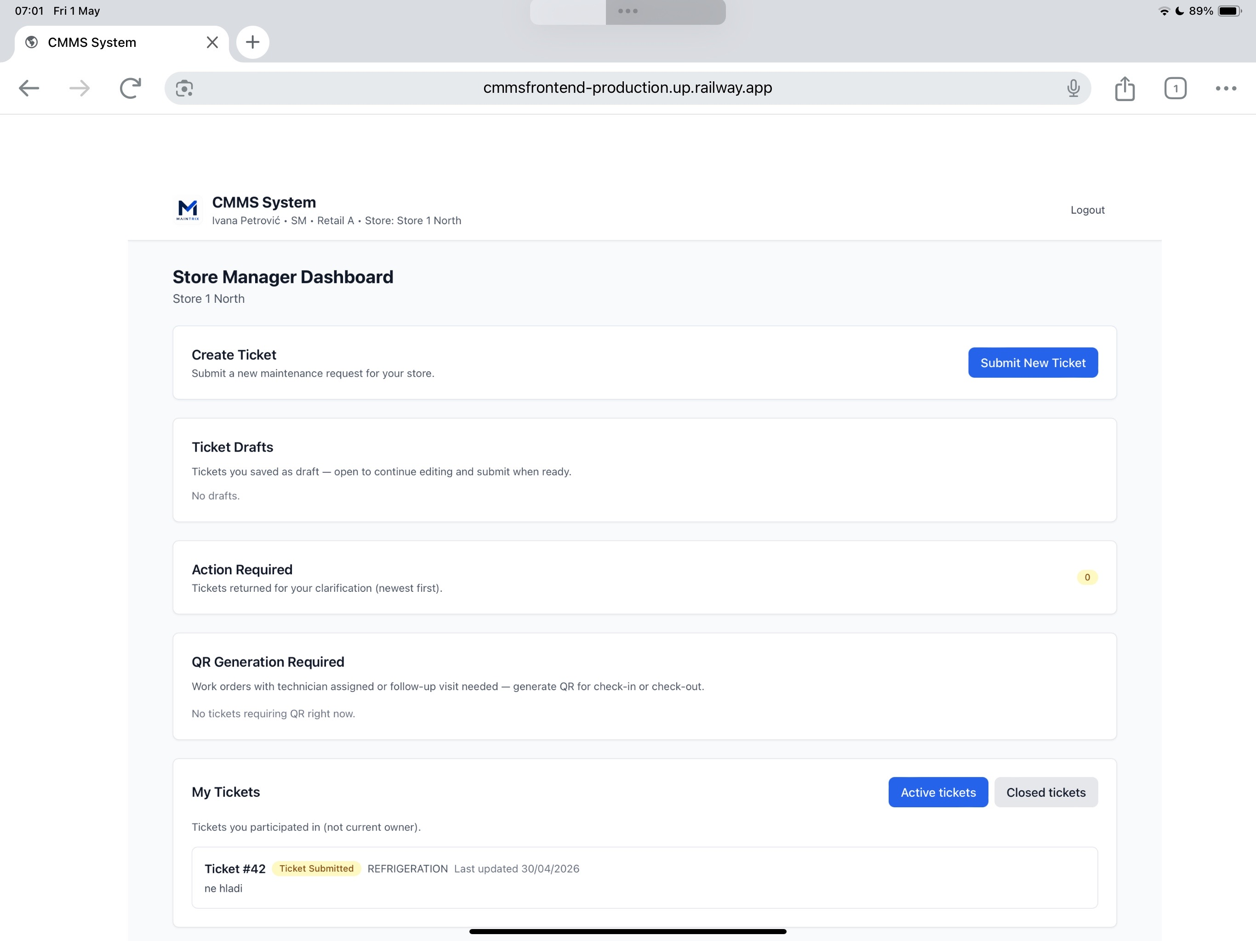

05 – Submit Ticket Form
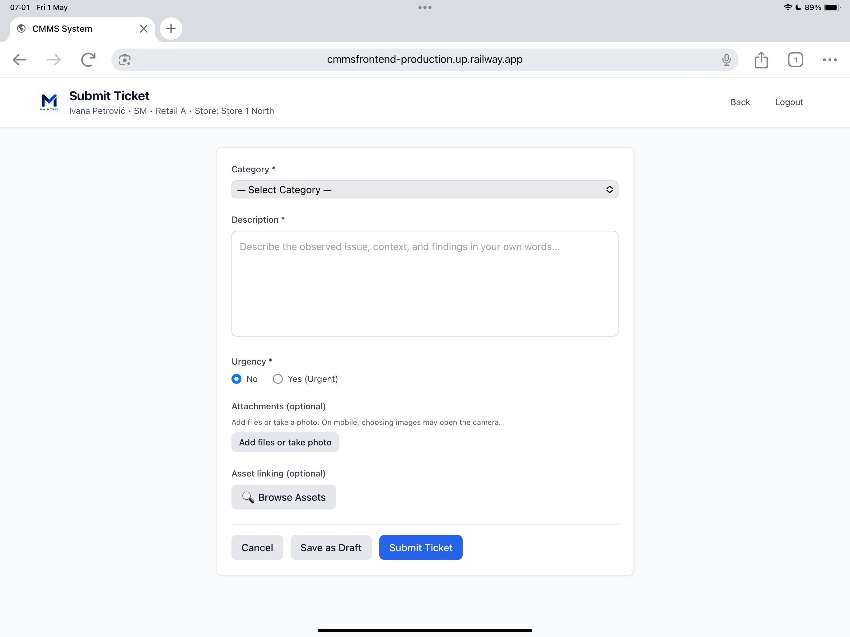

06 – Category Selection
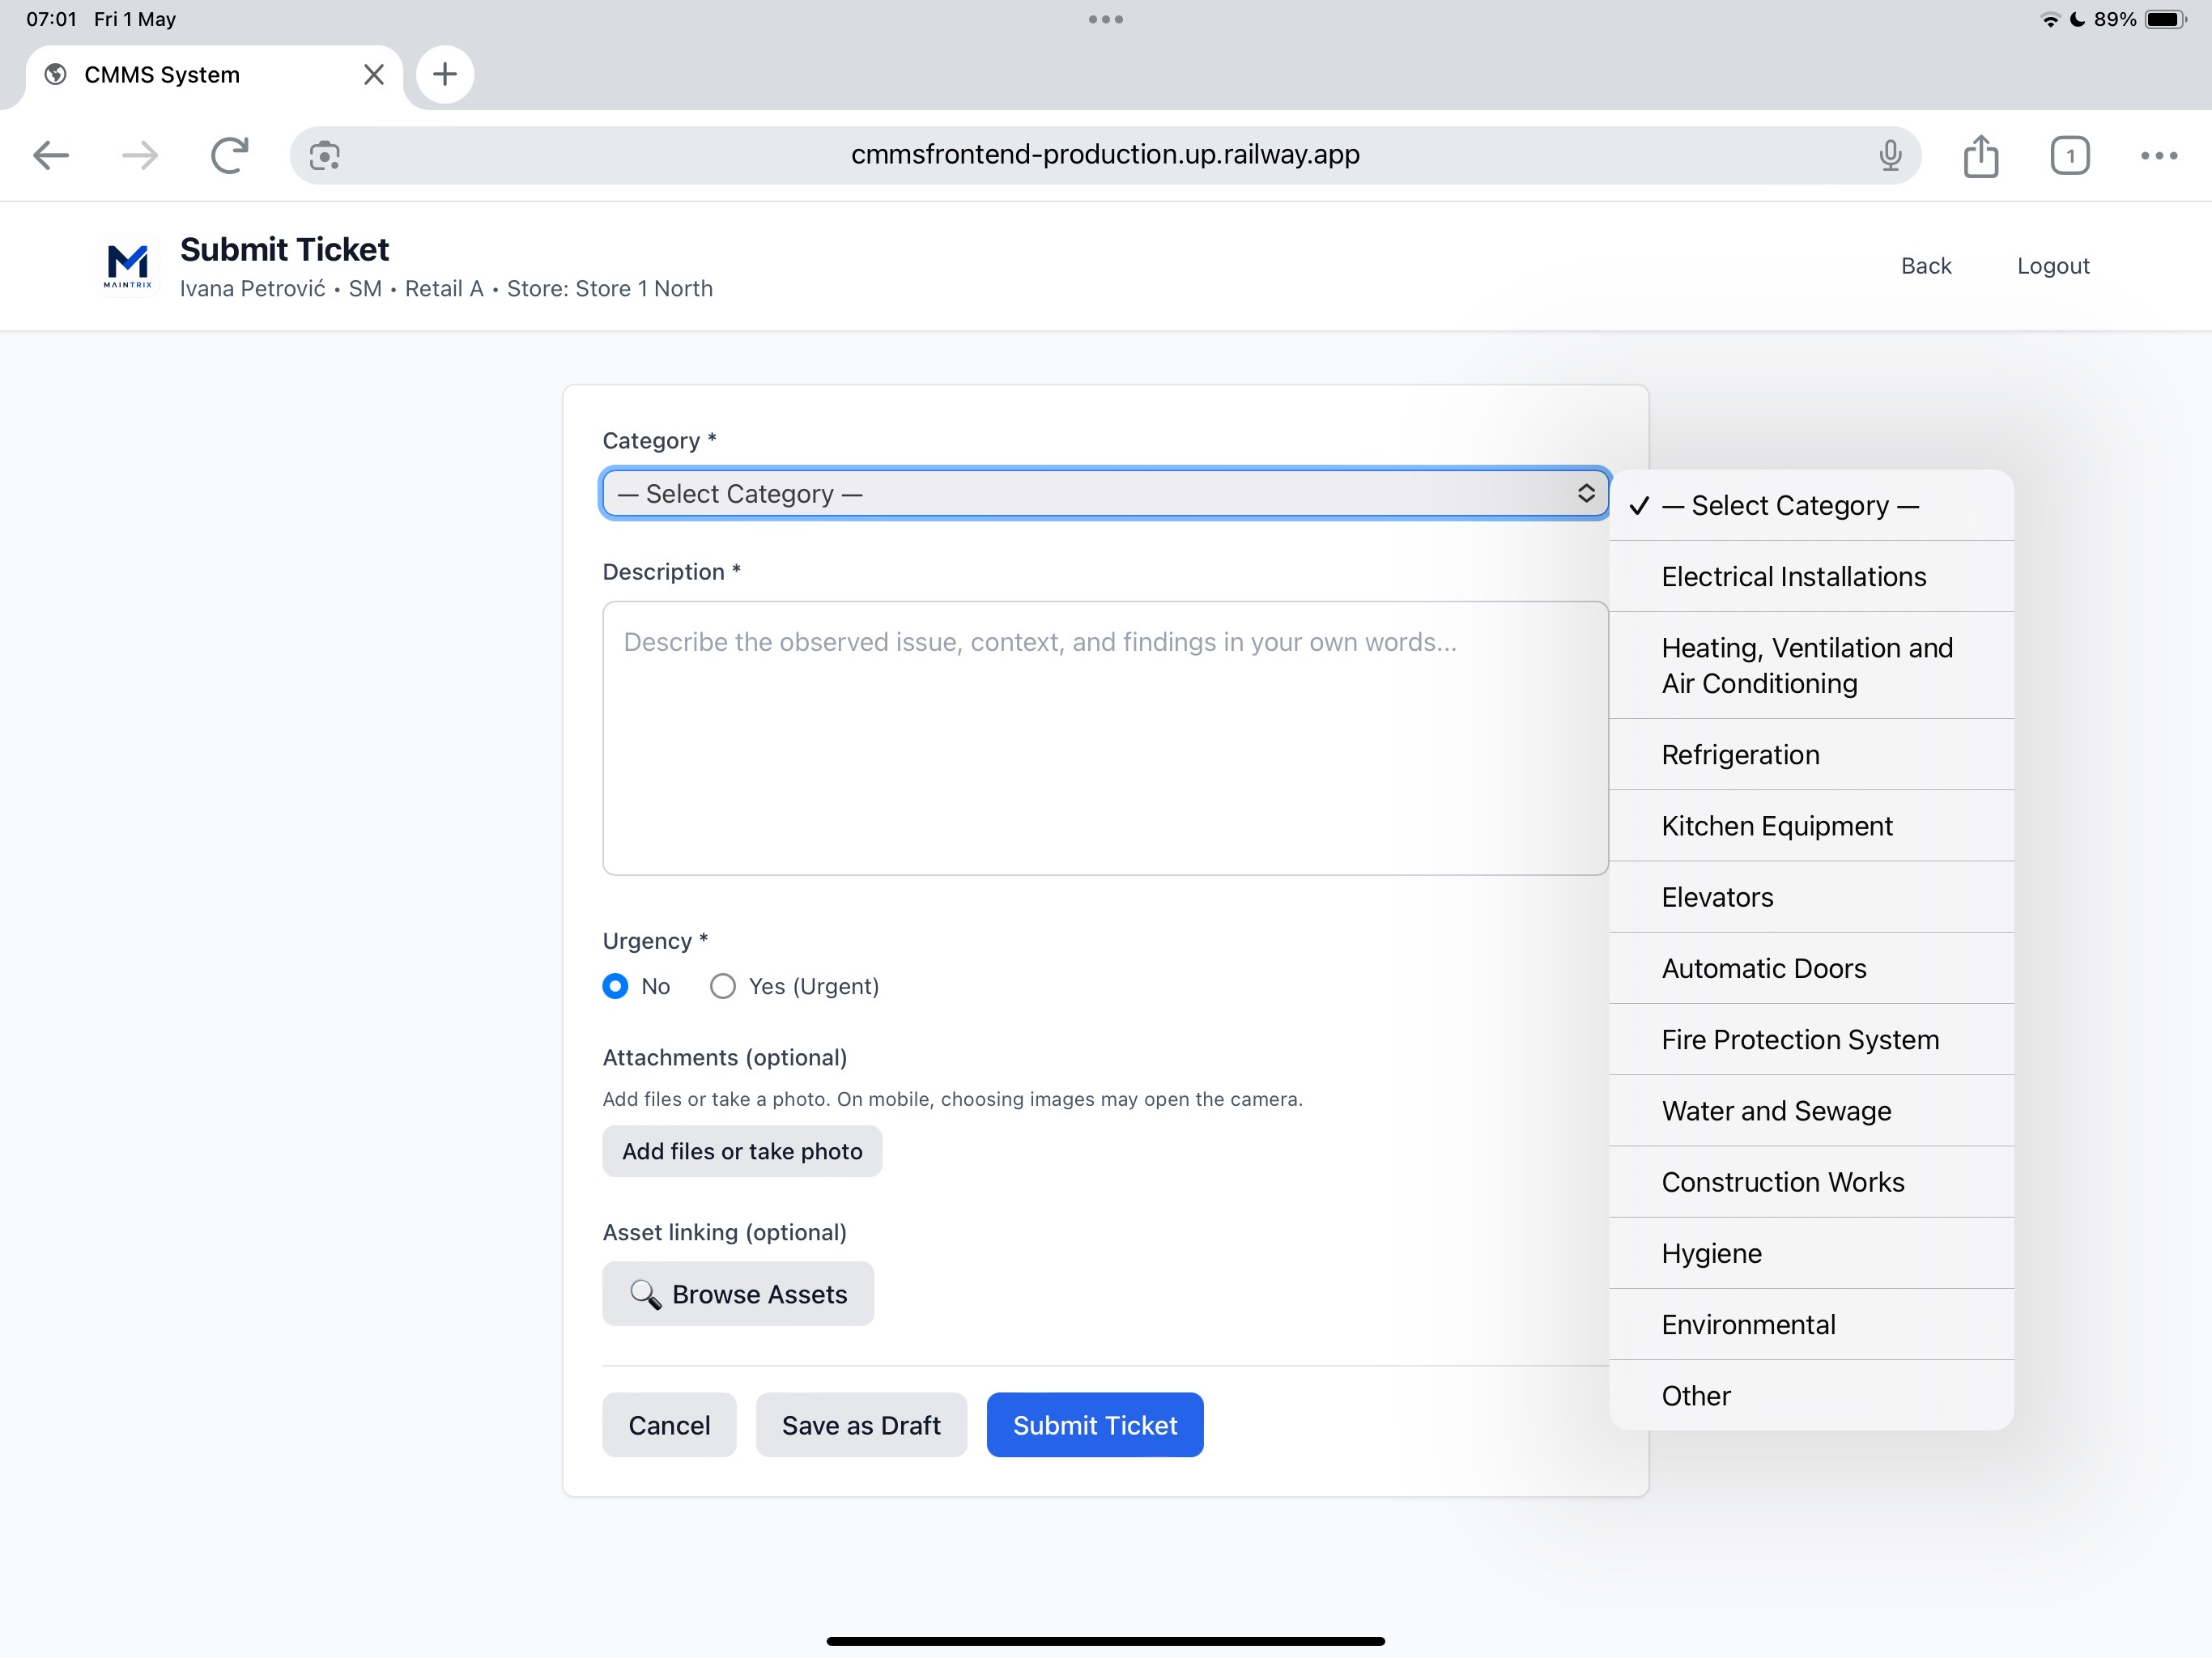

07 – Asset List
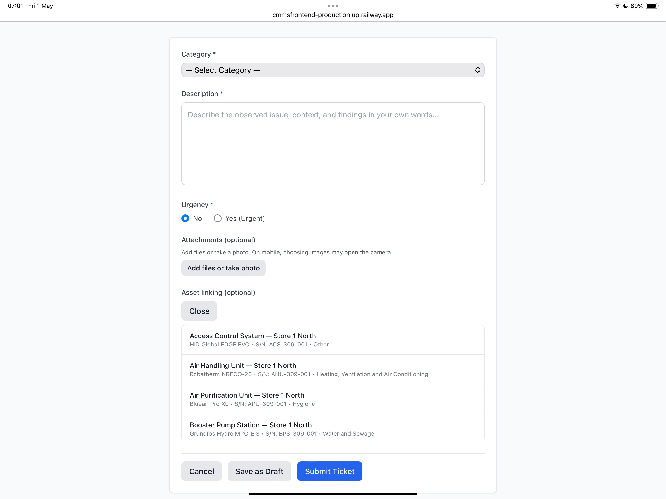
Komentar: Čudno je da se lista asseta pojavljuje dolje ispod forme. U slučaju realne velike liste, ovo je neupotrebljivo.

08 – Asset Auto-Category Mapping
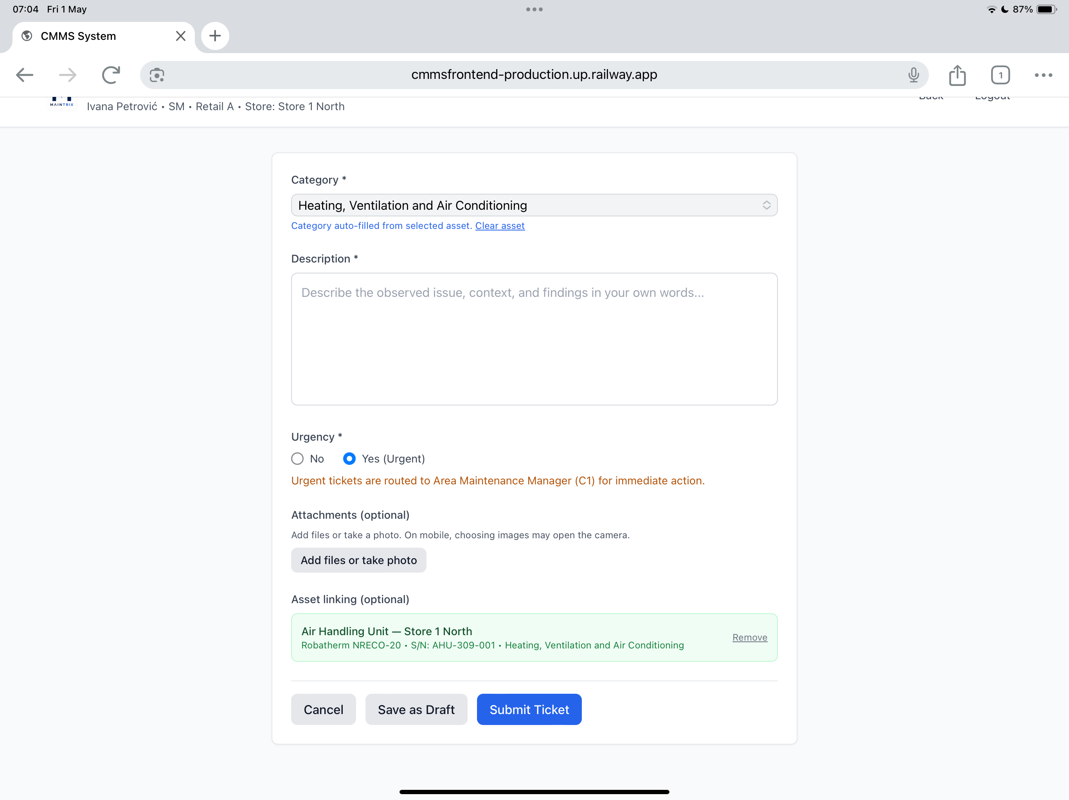

09 – Urgent Ticket Example
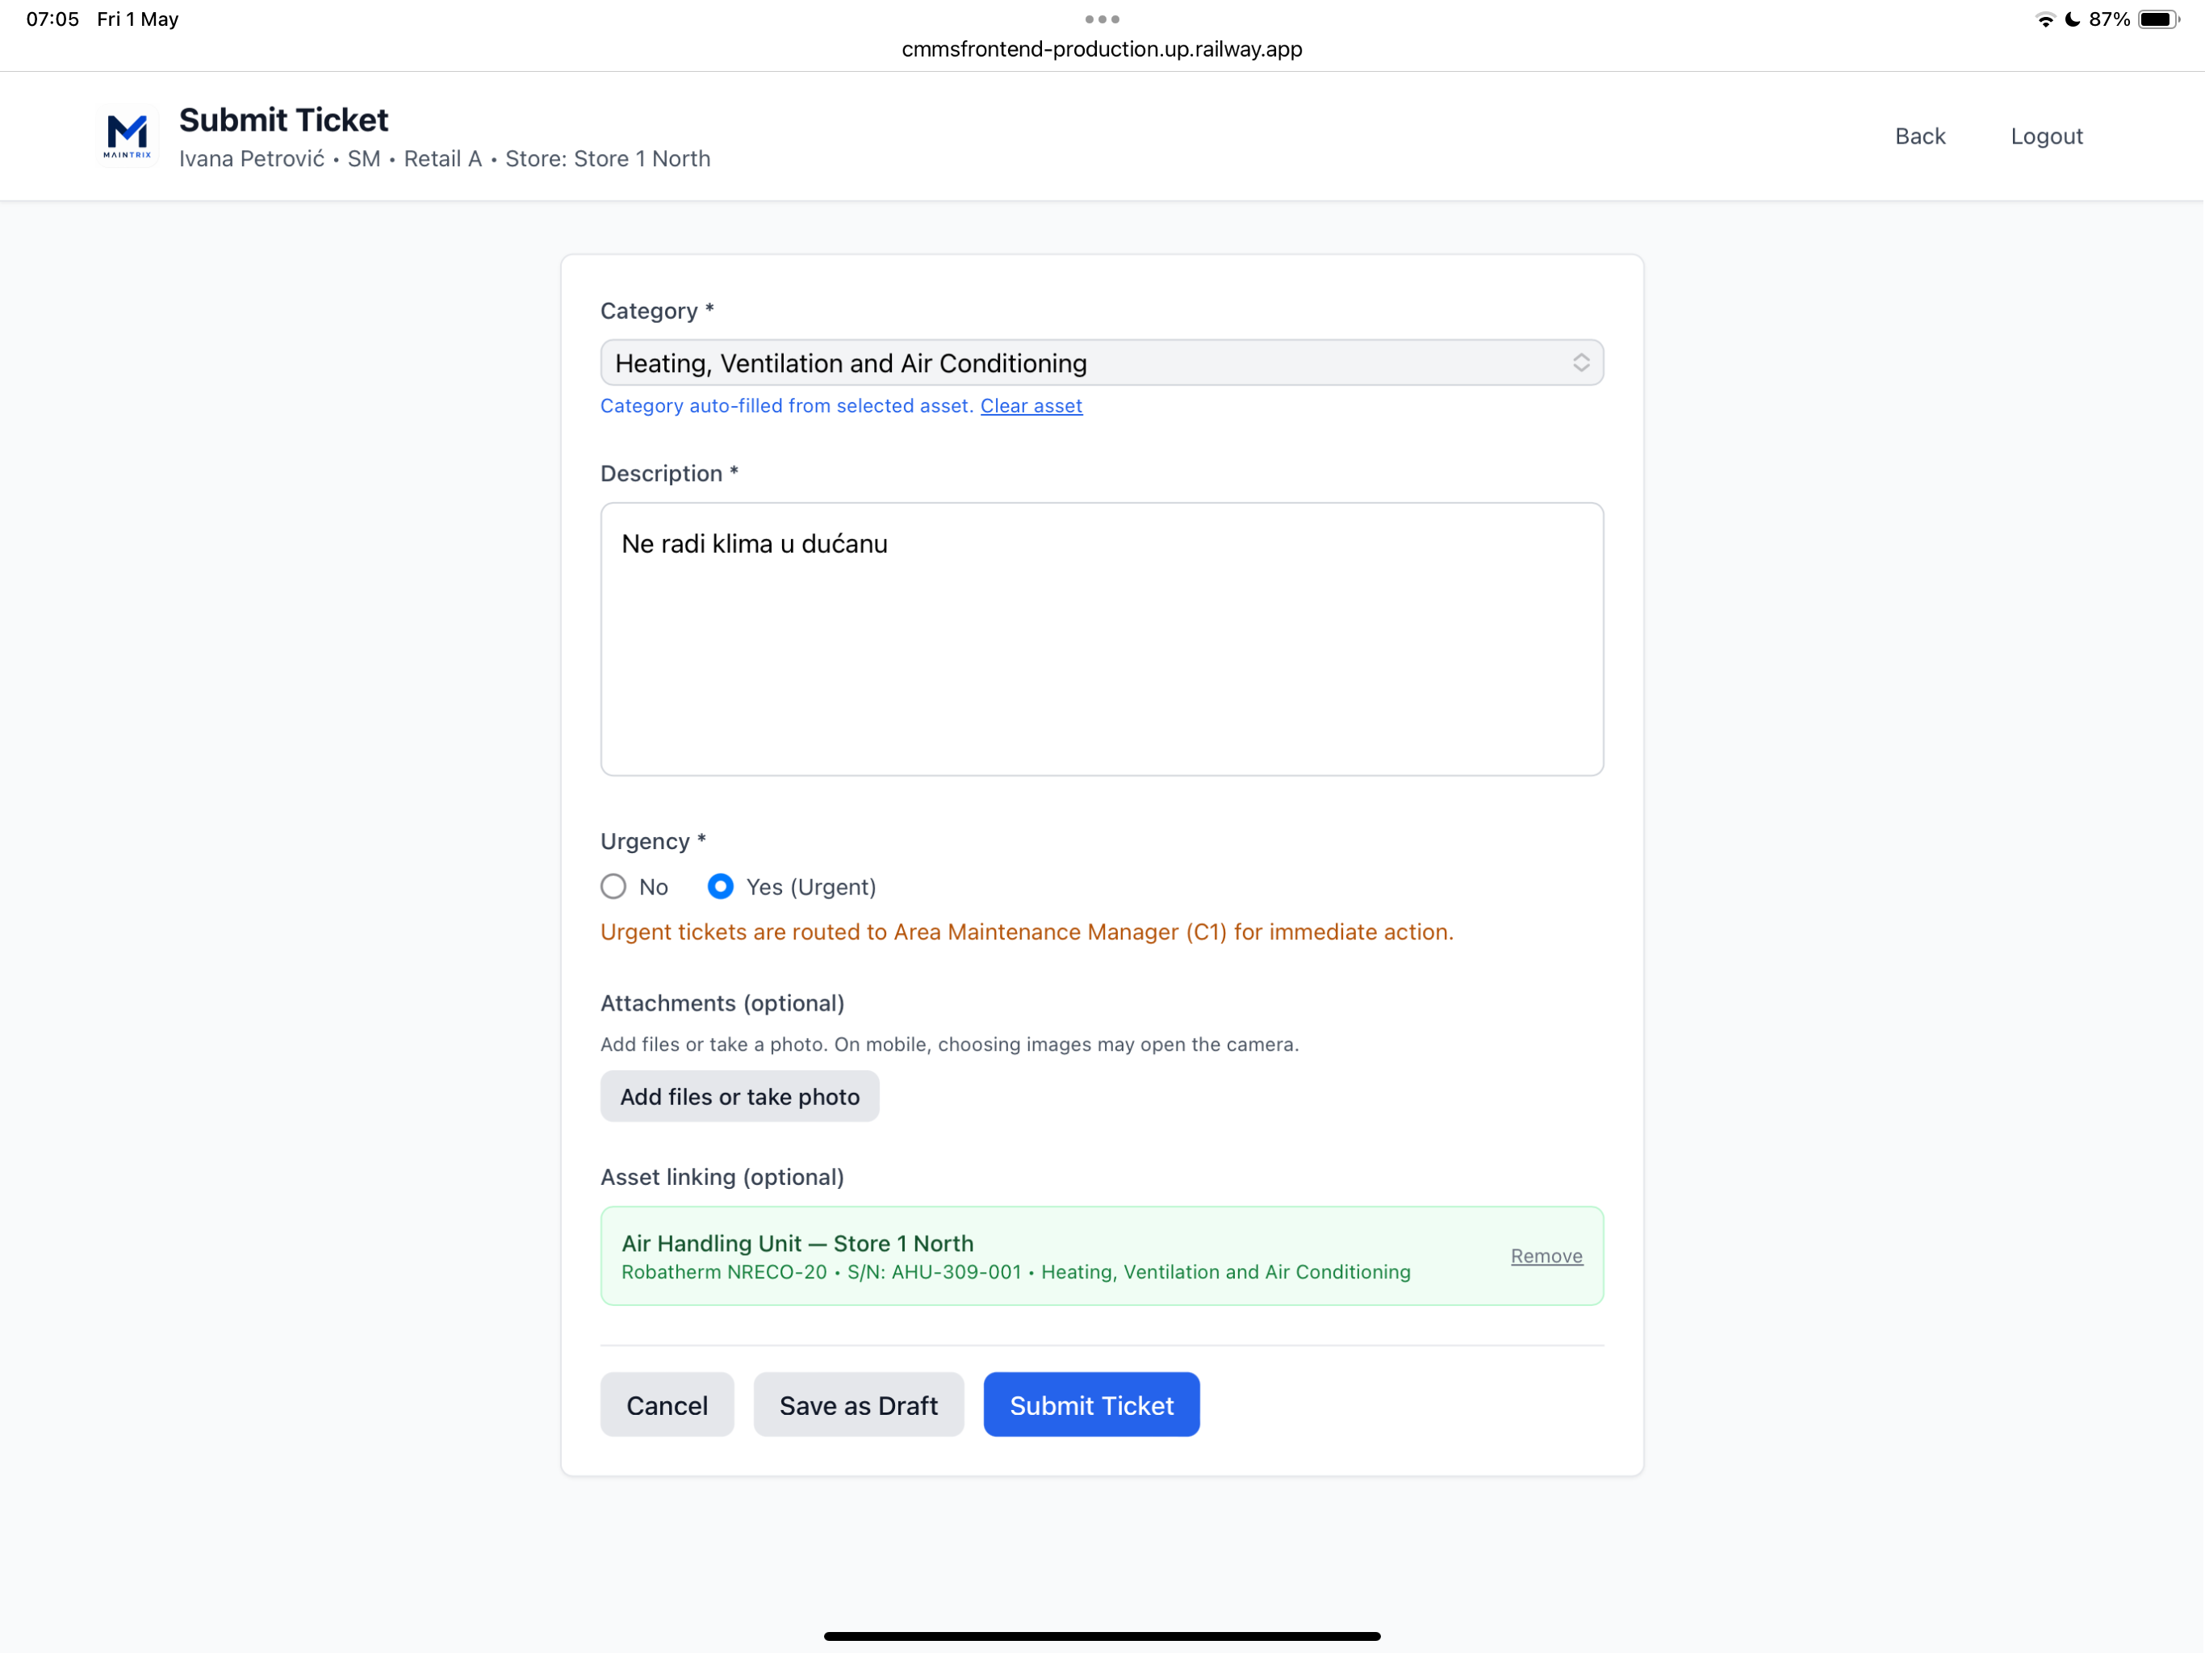

10 – Ticket Submitted Confirmation
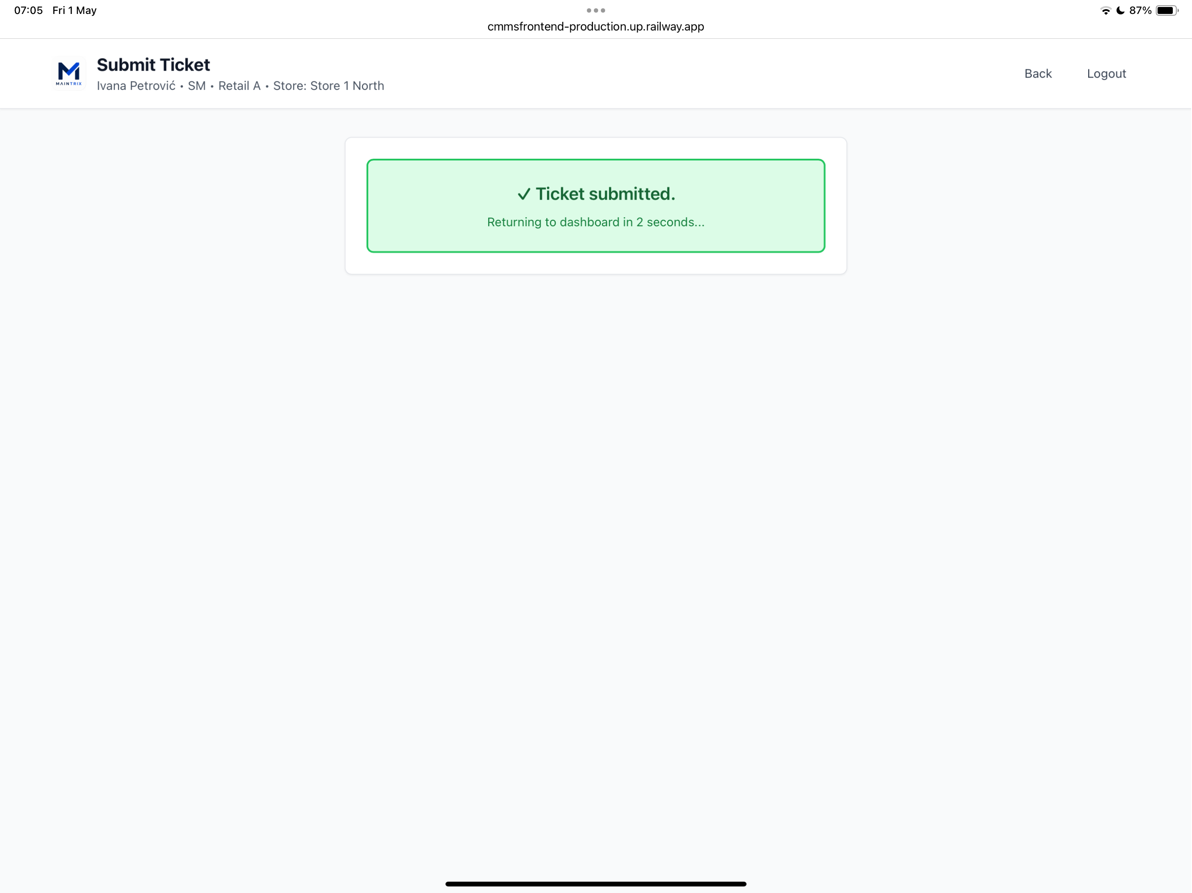

11 – Ticket Visible on Dashboard
